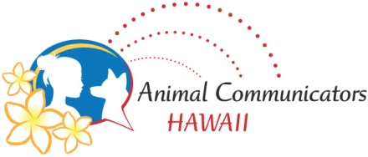REGISTRATION AND WAIVER

Client’s name _____________________________________ Today’s Date _____________________
Animal’s name ____________________________________ Species _________________________
Animal’s physical address ______________________________________________________________
Client’s email address _____________________________ Phone number ___________________
Service(s) being requested:
_____ Health challenge _____ Transitioning/afterlife _____ Communication
_____ Behavioral issue _____ Lost animal _____ Other
Please elaborate on your concerns and list any questions you may have
____________________________________________________________________________________
____________________________________________________________________________________
____________________________________________________________________________________
Please read and sign below:
- I am of legal age, agree to the services to be performed on myself and responsible for payment of services provided by the practitioner (if applicable).
- For animal services:
  - I am the legal guardian of the animal descrbed on this form, agree to the services to be performed and responsible for payment of services provided by the practitioner (if applicable).
  - I understand that the practitioner is not a veterinarian or animal behaviorist and any information shared during the consultation does not replace the medical care and advice provided by a licensed veterinarian or animal behaviorist.
  - I am open to animals having free will and that they cannot be compelled to behave in a certain manner or agree to share the information that they provide; they can choose to do so.
  - For lost animals, information provided is good only for a brief time, as animals can move; the search is a single consultation and is not guaranteed to result in the return of the animal.
I hereby hold harmless and release Eileen T Abe, Mana’o I’o LLC and Animal Communicators Hawaii, their associates and/or their agents, from liability connected any services performed, to any sharing of information, suggestions or advice given by Eileen T Abe, Mana’o I’o LLC and Animal Communicators Hawaii their associates and/or their agents that results in injury or death of themselves, their animal or damage/loss of personal property.

____________________________________________________ __________________________
Signature Date

